

ATAR Biology

Unit 2: Topic 4

Week 32 Gas Exchange

© SIDE

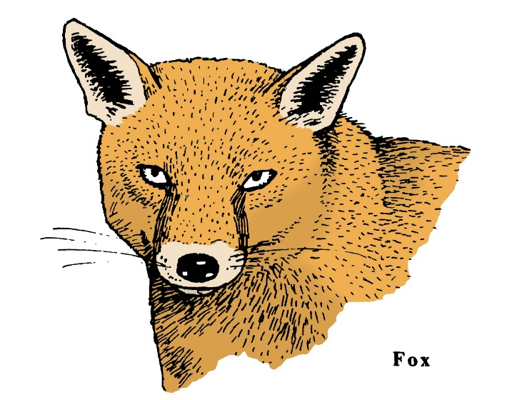

Student Study Notes

Unit Content
- In animals, the exchange of gases between the internal and external environments of the organism is facilitated by the structure of the exchange surface(s), including spiracles, gills, alveoli and skin.

The exchange of materials in multicellular animals

As mentioned in Topic 2, materials are able to move through the semipermeable membrane of a cell by the process of diffusion.

However, in multicellular organisms, many of the cells are not directly connected to the external environment so a direct exchange of materials is not possible.

In most animals, a network of blood capillaries carries oxygen and nutrients to the cells and takes away carbon dioxide and other wastes.

The exchange of materials in and out of the body cells of a multicellular animal is shown below.

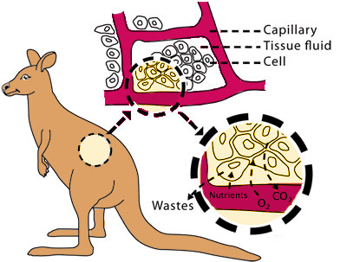
© WestOne

Most cells of multicellular animals are specialised to form tissues and organs and are bathed in a tissue fluid (also known as extracellular fluid) in which an exchange of materials takes place.

Extracellular fluid acts as the external environment in multicellular animals, by providing the requirements of each cell and receiving waste products.

The exchange of gases
In order to survive, cells need a constant supply of oxygen, and carbon dioxide needs to be removed. Gases are exchanged across a moist surface by the process of diffusion. The surface must be moist as the gases need to be in solution. Animals have specialised structures such as skin, lungs, gills and trachea for the exchange of gases with the environment.

In animals, the exchange of gases between the internal and external environments of the organism is facilitated by the structure of the exchange surface(s), including spiracles, gills, alveoli and skin
Spiracles
Trachea are branched tubes within an insect's body and are the organs that aid gas exchange. Air enters through holes in the abdomen called spiracles. Spiracles are also found in other arthropods including millipedes. Oxygen diffuses across the fluid-filled ends of the trachea into the body cells. Carbon dioxide diffuses out of the cells and into the trachea.
Spiracles can be seen as bright markings on many caterpillars. Arachnids such as spiders have similar structures called book lungs.
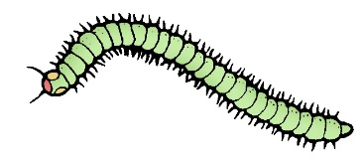
© SIDE
Gills
Gills are the organs that aid gas exchange in fish, crustaceans, molluscs, aquatic insect larvae, amphibians at the tadpole stage and tube worms. Gills consist of many rows of gill filaments, which greatly increase the surface area.
In fish, as water passes from the mouth to the gills, dissolved oxygen diffuses across the gill filaments into the blood. Carbon dioxide moves out of the blood by diffusion and across the gills.

Alveoli
Lungs are the organs that aid gas exchange in mammals, birds, reptiles and amphibians. Air enters the lungs when the animal inhales and oxygen diffuses across the surface of tiny air sacs called alveoli and into the blood. Alveoli greatly increase the surface area for the exchange of gases. Carbon dioxide moves out of the blood and crosses the surface of the alveoli in the opposite direction. The air in the lungs is then exhaled.

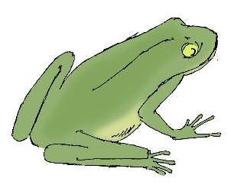
Skin
Amphibians and earthworms are able to exchange gases with the environment through their skin. The skin needs to be kept moist to dissolve the oxygen and excrete carbon dioxide. Most amphibians also possess lungs which aid gas exchange when they are very active.
© SIDE

PRACTICE QUESTIONS
1. By what process does oxygen enter the cells?

2. Why do oxygen and nutrients leave the capillaries and enter cells?

3. Why do carbon dioxide and other wastes leave the cell?

4. Explain the purpose of gas exchange in an organism.

5. Describe three properties that all gas exchange surfaces have in common and state the significance of each.

6. Identify the main structures used in gas exchange for each organism:

a) Fish:
b) Amphibians:
c) Mammals:
d) Insects:

7. Describe the process of gas exchange in mammals.

8. Describe the process of gas exchange in bony fish.

